Cinema Program of Cartoons on the Bay 2023
CINETEATRO MASSIMO, Pescara 1st – 3rd OF JUNE

_______________________________________________________________________________________

JUNE 1st
4:00 PM - Screen 4
FILM IN COMPETITION: “OOPS, I MURDERED THE PERSON THE PERSON I LIKE LIKES”
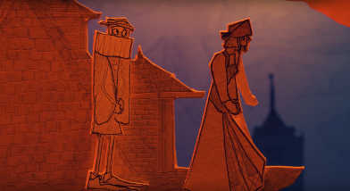
Orazio is in love with Bellimperia, Don Andrea’s bride-to-be. As the Spanish army rides westwards to repress a Portuguese rebellion, Orazio has the chance to kill Andrea and take his place, but when the Spanish lose the war against the Portuguese, Orazio finds himself involved in an even bigger scheme…
Directed by Ross Ozarka
Suitable for all – Running time 50’
New Zealand

JUNE 1st
6:00 PM - Screen 4
FILM IN COMPETITION: “FORBIDDEN WORLD”
Action, adventure, and humour in a thrilling old-style scientific fiction film. Two space adventurers cross the galaxy to find a legendary treasure. They will face gigantic robots, savage aliens, and carnivorous trains in a dangerous trip towards the forbidden world.
Directed by Alê Camargo & Camila Carrossine
Suitable for all – Running time 95’
Brazil

JUNE 1st
6:00 PM - Screen 5
RETROSPECTIVE: “CHICKEN RUN”
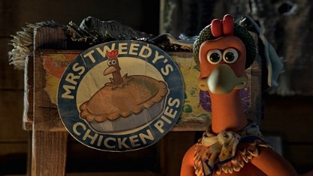
A group of chickens, intensively exploited to produce eggs, decides to rebel against their destiny and tries to escape in any way possible from the Tweedys’ breeding farm, a family of cruel farmers.
Directed by Peter Lord & Nick Park
Children/Teenagers movie - Running time 84’
United States, United Kingdom, France

JUNE 1st
9:00 PM - Screen 2
PREVIEW: “KNIGHTS OF THE ZODIAC”
Seiya, a very stubborn boy, is an orphan who lives on the street trying to scrape together money through underground fighting. In fact, the young man is not the only survivor of the family: as a matter of fact, he is desperately looking for his sister, who has been kidnapped. During one of his fights, Seiya manages to access to a source of mystic powers, of which he was unaware. The boy finds himself thrown in a world unknown to him, where he undergoes a magical training to fulfil a mission. In fact, his task is to protect a war goddess.
Directed by Tomek Baginski
Suitable for teenagers and older - Running time 152’
Japan, Hungary, USA

______________________________________________________________________________________

JUNE 2nd
4:00 PM - Screen 4
FILM IN COMPETITION: “BRICHOS 3 – MEGAVIRUS”
A bio-digital virus invades the minds of the inhabitants of Vila dos BRICHOS (Brazilian animals) through digital screens. The protagonists will have to enter people’s dreams to free them from the disease.
Directed by Paulo Munhoz
Children/Teenagers movie - Running time 74’
Brazil

JUNE 2nd
4:00 PM - Screen 5
FILM IN COMPETITION: “CRICKET & ANTOINETTE”
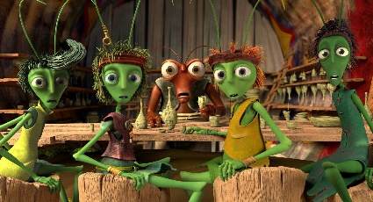
Can the improbable friendship between the rebellious ant Antonietta and the carefree cricket Ket change the world? Through a series of adventures, their bond connects ants and crickets, realising that a good life is made of both work and fun.
Directed by Luka Rukavina
Children/Teenagers movie - Running time 82’
Croatia

JUNE 2nd
6:00 PM - Screen 4
FILM IN COMPETITION: “MY GRANDFATHER'S DEMONS”
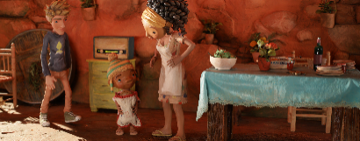
Rosa’s demanding life is completely dedicated to her job. The news of her grandfather’s death causes her an unexpected breakdown, making her question her choices. She decides to go back to the place where she was raised up at her grandfather’s side.
Directed by Nuno Beato
Suitable for all - Running time 84’
Portugal

JUNE 2nd
6:00 PM - Screen 5
RETROSPECTIVE: “WALTZ WITH BASHIR”
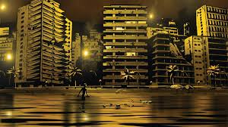
Because of a recurring dream his friend revealed to him, the director and screenwriter Ari Folman realises he has almost completely removed his youth, the time when he had been enlisted in the troops of the Israeli army in Lebanon.
Directed by Ari Folman
Suitable for teenagers and older - Running time 90’
Israel, Germany, France

JUNE 2nd
8:00 PM - Screen 4
RETROSPECTIVE: “THE CONGRESS”
The Congress is a film which combines live action, animation, and science fiction. Through the illusory myth of eternal youth, its story shows a world that is gradually becoming an Orwellian psychedelic nightmare.
Directed by Ari Folman
Suitable for teenagers and older - Running time 122’
France, Israel, Belgium, Poland, Luxembourg, Germany

JUNE 2nd
8:00 PM - Screen 5
FILM IN COMPETITION: “METAMORPHOSIS”
Inspired by Farid al-Din 'Attar’s “The Conference of the Birds”, this film is about a flock of thousands of birds following Upupa towards the Mount Qaf, the house of King Simurgh, who can answer all their questions. The secret will be revealed only to few of them.
Directed by Michele Fasano
Suitable for all - Running time 106’
Italy

JUNE 2nd
10:00 PM - Screen 4
FILM IN COMPETITION: “THE AMAZING MAURICE”
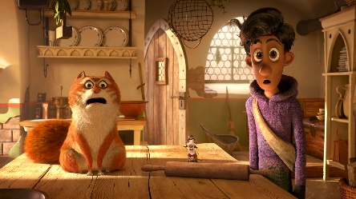
Stories of rats and rat pipers are known to all towns of Discworld. The streetwise cat Maurice leads a group composed by educated friends and a boy, earning a good income, until they bump into someone playing a different tune. Now Maurice and his rats must learn a new concept: evil…
Directed by Toby Genkel
Children/Teenagers movie - Running time 93’
Germany

JUNE 2nd
10:00 PM - Screen 5
RETROSPECTIVE: “The Pirates! In an Adventure with Scientists!”
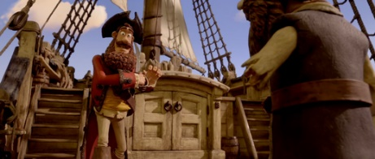
A Pirate Captain strives to find a way to defeat his opponents Black Bellamy and Cutlass Liz in the annual Pirate of the Year competition. The mission will take the Captain and his crew far from the Blood Island coast to the foggy streets of the Victorian London, in an adventurous trip with the young Charles Darwin, who is involved in the scientific expedition which will soon make him famous…
Directed by Peter Lord & Jeff Newitt
Children/Teenagers movie - Running time 88’
United Kingdom, United States
______________________________________________________________________________________

JUNE 3rd
6:00 PM - Screen 4
FILM IN COMPETITION: “MY BIG BIG FRIEND”
In this animated musical film, Yuri, Lili and Matt, along with their Big Big Animal friends Golias, Nessa and Bongo will have their biggest adventure yet! They will travel to a strange new world where they will meet Doodle Doubt - a strange creature that will test their friendship and self-confidence.
Directed by Andrés Lieban
Children/Teenagers movie - Running time 78’
Brazil

JUNE 3rd
6:00 PM - Screen 5
FILM IN COMPETITION: “JUNGLE BEAT 2 THE PAST”
“Jungle Beat 2 The Past” is the dino-sized sequel to “Jungle Beat: The Movie”. The stegosaurus Clarence mysteriously appears in the African jungle, carrying Munki and Trunk in a Jurassic-format adventure with time travels, aliens, action, and laughs for the whole family!
Directed by Sam Wilson
Children/Teenagers movie - Running time 87’
Mauritius

JUNE 3rd
8:00 PM - Screen 4
FILM IN COMPETITION: “THE MOVIE WILLBENGERS: MYSTERIOUS CAMPING”
Sam experiences a difficult moment every day. The Hammingtons go camping to escape the ordinary life and enjoy freedom. While Sam is unpacking their things, William and Bentley discover an abandoned playground. They unexpectedly get to know a little Gumiho called Miho and quickly become friends.
Directed by Ryoo Jeong-woo & Shin Chang-hwan
Children/Teenagers movie - Running time 72’
South Korea

JUNE 3rd
8:00 PM - Screen 5
FILM IN COMPETITION: “SALEEM”
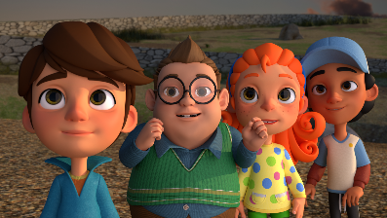
Set in a small town in the Middle East, “Saleem” is a powerful and uplifting story of hope, resilience, friendship, and community, through the lens of a nine-year-old boy. Saleem arrives in the new town, carrying his burdens of the past, after losing his father and experiencing displacement with his mother and two siblings. Outside their small rooftop apartment, Saleem finds a wooden chest: a mysterious pigeon invites him to open it, revealing what seems to be a treasure map. Saleem undertakes a treasure hunt adventure full of clues, challenges, healing, and victory; an adventure that changes his life.
Directed by Cynthia Madanat Sharaihaore
Suitable for all - Running time 90’
Jordan

JUNE 3rd
10:00 PM - Screen 4
FILM IN COMPETITION: “WHERE IS ANNE FRANK”
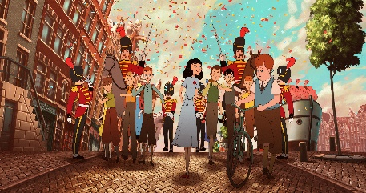
Where is Anne Frank begins with a miracle: Kitty, Anne Frank’s imaginary friend to whom she addressed her famous diary, comes alive in contemporary Amsterdam. Kitty begins a feverish search throughout today’s Europe to find her beloved friend.
Directed by Ari Folman
Suitable for all - Running time 99’
Belgium

